CONNECTED, LEVEL 3 2014, Why Is That?  The Tsunami That Washed Time Away  by Jenna Tinkle  Overview  Geologists James Goff and Scott Nichol had an idea that the landscape at Henderson Bay in Northland was suddenly changed by a huge tsunami that took place hundreds of years ago. This article describes how they used evidence to support their ideas.  A Google Slides version of this article is available at www.connected.tki.org.nz. |  |  | 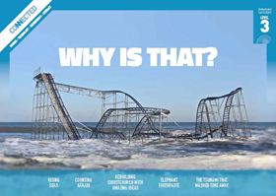  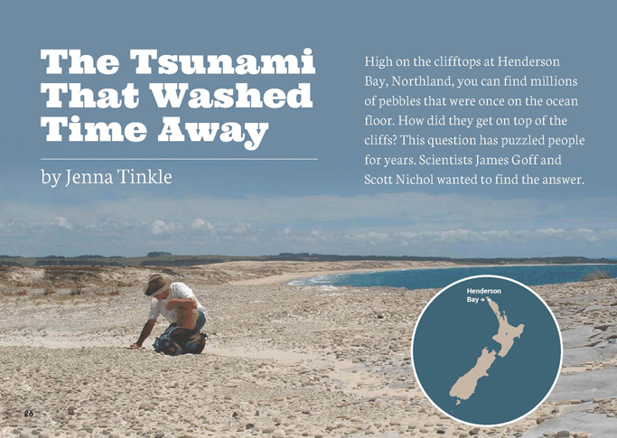
Science capability: Use evidence |  | Text characteristics

Science is a way of explaining the world. Science is empirical and measurable. This means that in science, explanations need to be supported by evidence that is based on, or derived from, observations of the natural world. Students should be encouraged to support their ideas with evidence and look for evidence that supports or contradicts other explanations.  At the core of science is theory building – making better explanations. What sets scientific explanations apart from other ways of explaining the world is their reliance on evidence and their ability to evolve as new evidence comes to light.  For more information about the “Use evidence” science capability, go to http://scienceonline.tki.org.nz/Introducing-five-science-capabilities/Use-evidence |  | - A significant amount of vocabulary that will be unfamiliar to some students (including subject-specific words and phrases and words in te reo Māori), which is generally explained through words or illustrations.  - Abstract ideas accompanied by concrete examples that help support students' understanding.  - Maps, photographs, an illustration, and diagrams that clarify or extend the text and may require some interpretation.

Curriculum context

SCIENCE
NATURE OF SCIENCE: Understanding about science  Achievement objective(s)  L3: Students will:  - Appreciate that science is a way of explaining the world and that science knowledge changes over time.  - Identify ways in which scientists work together and provide evidence to support their ideas. |  | PLANET EARTH AND BEYOND: Earth systems  Achievement objective(s)  L3: Students will appreciate that water, air, rocks and soil, and life forms make up our planet and recognise that these are also Earth’s resources. |  | Key Nature of Science ideas  - Evidence is based on, or derived from, observations of the natural world.  - Scientific ideas and explanations are supported by evidence.  - Scientists use relevant evidence to support or revise their predictions (hypotheses) and explanations.  Key science ideas  - A tsunami can be caused by the eruption of an underwater volcano.  - Changes to the land affect the plants and animals that live there.  - Fossils and patterns in the soil and rocks provide evidence about previous life and living conditions on Earth.

ENGLISH

READING  Ideas  Students will show a developing understanding of ideas within, across, and beyond texts. |  | INDICATORS  - Uses their personal experience and world and literacy knowledge confidently to make meaning from texts.  - Makes meaning of increasingly complex texts by identifying main and subsidiary ideas in them.  - Starts to make connections by thinking about underlying ideas in and between texts.  - Makes and supports inferences from texts with increasing independence. |  | THE LITERACY LEARNING PROGRESSIONS  The literacy knowledge and skills that students need to draw on by the end of year 6 are described in The Literacy Learning Progressions.

Using evidence

- Scientists use empirical evidence to develop theories about how the world works.
- Empirical evidence is data gathered from observations and experiments.
The science capability, Use evidence, is about students developing and considering theories and explanations in the light of evidence (http://scienceonline.tki.org.nz/Introducing-five-science-capabilities/Use-evidence).
Students should be:
- using evidence they have gathered to develop their own explanations about the way the world works
- critiquing explanations offered by others, including scientifically accepted explanations, by considering the evidence that supports them.
Scientific explanations, including those found in museums, in television programmes, on the Internet, and in non-fiction books and texts, often fail to discuss the evidence and testing that led to the development of these explanations.
Teachers can:
- help students to be more critical consumers of science information by being explicitly critical themselves
- model a sceptical stance
- ask questions such as:
  - How do you think people found that out?
  - What kind of evidence would support that idea?
  - How could a scientist test that idea?
- use concept cartoons to propose possible explanations. (See http://conceptcartoons.com/what-is-a-concept-cartoon-.html)
When doing practical investigations, teachers can support students to:
- consider a range of possible explanations for their findings
- think about how these explanations fit with the evidence they have gathered
- avoid suggesting that scientific investigations prove anything - rather, investigations provide evidence that supports or refutes a hypothesis or idea.
Establish a science classroom culture by:
- welcoming a range of possible explanations
- encouraging students to consider possible explanations in the light of evidence
- having students draw evidence from their experience
- using questions such as:
  - What have we seen today that supports X’s idea?
  - Has anyone seen anything somewhere else that might be evidence for X’s idea?
- encouraging investigation:
  - What could we do to test X’s idea?
  - What would we expect to happen? Why?
A range of questions and activities designed to get students to use evidence is available on the Science Online website: http://scienceonline.tki.org.nz/Introducing-five-science-capabilities/Use-evidence

Meeting the literacy challenges

The following instructional strategies will support students to understand, respond to, and think critically about the information and ideas in the text. After reading the text, support students to explore the key science ideas outlined in the following pages.

TEACHER resources

Want to know more about instructional strategies? Go to:
- http://literacyonline.tki.org.nz/Literacy-Online/Teacher-needs/Reviewed-resources/Reading/Comprehension/ELP-years-5-8
- “Engaging Learners with Texts” (Chapter 5) from Effective Literacy Practice in Years 1 to 4 (Ministry of Education, 2003).
Want to know more about what literacy skills and knowledge your students need? Go to:
- http://literacyonline.tki.org.nz/Literacy-Online/Student-needs/National-Standards-Reading-and-Writing
- www.literacyprogressions.tki.org.nz/
“Working with Comprehension Strategies” (Chapter 5) from Teaching Reading Comprehension (Davis, 2007) gives comprehensive guidance for explicit strategy instruction in years 4–8.
Teaching Reading Comprehension Strategies: A Practical Classroom Guide (Cameron, 2009) provides information, resources, and tools for comprehension strategy instruction.

INSTRUCTIONAL STRATEGIES

FINDING THE MAIN IDEAS
Read the title and the hook. PROMPT the students to identify their purpose for reading and make predictions.
- What is the question that the scientists want to answer?
- What explanation can you suggest?
- What sort of evidence might help test that idea?
What will you look for as you read?
PROMPT the students to make links to their prior knowledge.
What do you already know about the Ring of Fire? Or about tectonic plates? Or about tsunamis?
ASK QUESTIONS to help the students locate information.
- What evidence did the scientists find at Henderson Bay?
What evidence did they find in the swamp?
PROMPT the students to notice the devices the author uses to help readers track information, making links to previous ideas and information.
In the first paragraph on page 28, the author says the geologists “found clues”. How does the author show us what the main clues are? (“a big clue”)
To check the students’ understanding, have them RECORD what they have learned by carrying out one of the following writing activities in pairs:
- Use information from the text to write an explanation for the evidence found at Henderson Bay.
- Use evidence from the text to explain how objects might end up in middens and how they might help tell the “story” of the past.
- Describe the causes of tsunamis and their effect on New Zealand’s coastline.
Explanations could be in the form of flow charts. Co-construct the features of flow charts, using examples. Support students to identify and order key points and stages in their explanations that would form a step in a flow chart.
Alternatively, students could co-construct a diagram of Henderson Bay and use the evidence provided in the text to annotate it.
Have the students use their scientific knowledge to critique each other's explanations.

USING DIAGRAMS TO CLARIFY THE TEXT
EXPLAIN that diagrams help the reader to understand ideas in the text. The labels are an important feature of diagrams. Look closely at the diagram of the core sample on page 30.
- What is this diagram representing? How do you know?
How does this help us to understand the information?
Check that the students understand the timeframes, especially the concept of the “missing years” in the core sample on page 30. You could demonstrate this visually by stretching out a tape measure.
Imagine every centimetre represents 1000 years. This is the 600-year point and this is the 24,000-year point. All the information in between is missing!

DEALING WITH UNFAMILIAR VOCABULARY
Before the reading, have the students SKIM the text and IDENTIFY and LIST the subject-specific vocabulary. After the reading, have students work in groups to complete a glossary of this vocabulary, almost all of which is explained within the text.

REFLECTING ON THE READING
Reread the final paragraph and EXPLAIN that science articles often end with a summary of key information. DISCUSS the message in the summary about the role of scientists and geologists in particular.
- What is the author's message?
Can you think of other examples of how geology can help us to understand the way the world works and to plan for the future?

Key science ideas
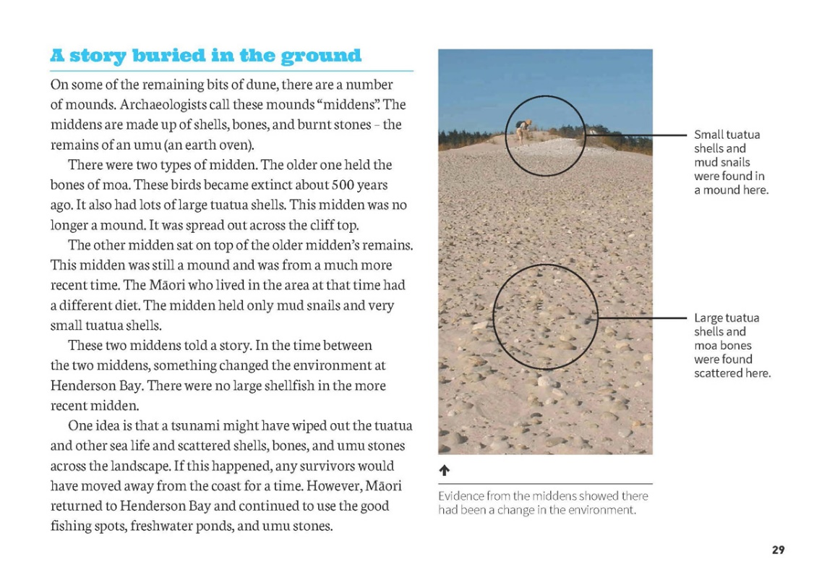 | Evidence is based on observations of the natural world.  Changes to the land affect the plants and animals that live there.  Scientific ideas and explanations are supported by evidence.
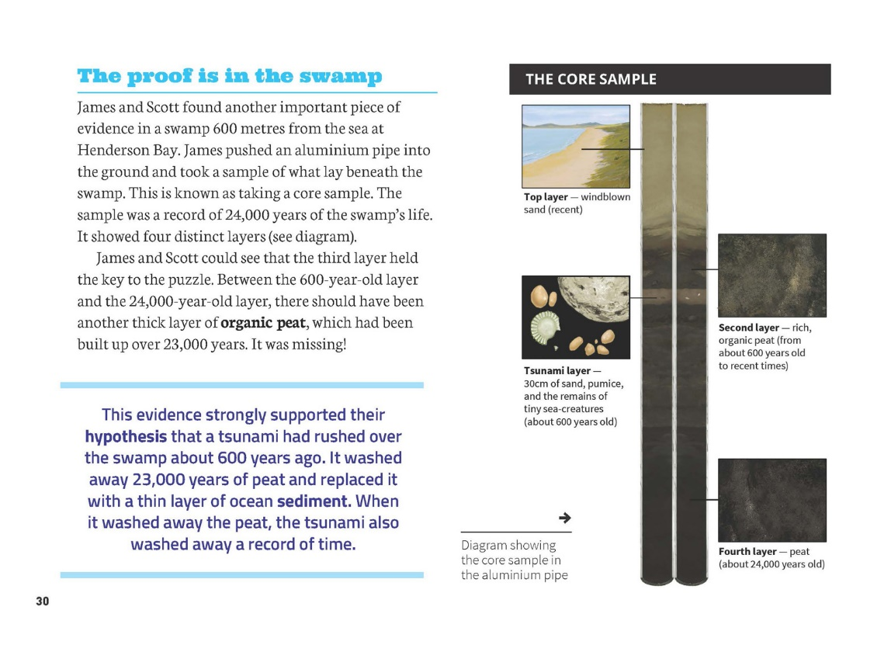 | Fossils and patterns in the soil and rocks provide evidence about previous life and living conditions on Earth.  Scientists use evidence to support or revise their predictions and explanations.  Scientists work together and provide evidence to support their ideas.

Exploring the science
Some activities focus directly on the science capability of “using evidence to support ideas” and the Nature of Science strand. Other activities extend student content knowledge. You are encouraged to adapt these activities to make the focus on Nature of Science explicit and to support students to develop the capability of using evidence to support ideas.

LEARNING FOCUS
Scientists use evidence to support their ideas.

LEARNING ACTIVITIES

Activity 1: Using evidence to support ideas about tsunamis
View the GNS video (www.youtube.com/watch?v=I5Vzio6ojkE&list=UUTL_U_K1eP4T885-JL3rVgw) in which a teacher uses a wave tank to show how a tsunami can create deposits in a coastal area.
Recreate this demonstration, using an inclined length of spouting with sand in the middle and water at the lower end. The students can generate a wave and watch sand being deposited up the “beach”. Start the activity with a question or hypothesis and have the students gather data to support or discount it.
Where do you think the beach material will end up?
Did the evidence support your prediction?
What happens if you change the slope of the beach or the size of the wave?
Now connect this learning to the Earth Learning Idea activity (www.earthlearningidea.com/English/Natural_ Hazards.html) that allows students to explore the Krakatoa eruption. It suggests two possible explanations for the series of tsunamis, which caused thousands of deaths. A simulation using a tank and a balloon allows the students to simulate the tsunamis and test one of the hypotheses: that the eruption created a crater (or caldera) below the sea and that this led to the collapse of one side of the volcano.
Extension
Participate in the LEARNZ fieldtrip that takes students to the Bay of Plenty to learn about geohazards, including volcanoes, tsunamis, landslides, earthquakes, and hydrothermal activity.

Activity 2: Using evidence from Earth to understand our world
The article demonstrates how scientists look for evidence to support their ideas about the forces that shape the Earth. The suggestions here are organised around particular foci.
Climate change
Use the Science Learning Hub activity “Whanganui Rocks and Climate Cycles” (www.sciencelearn.org.nz/ Contexts/Dating-the-Past/NZ-Research/Whanganui-rocks-and-climate-cycles) to learn how the study of fossils, combined with accurate dating, gives us a detailed picture of climate and environment changes in New Zealand over the last few million years. The activity includes an interactive that shows how sedimentary rocks near Whanganui reveal many climate cycles over the last 5 million years. It may raise questions in the students' minds about the causes and likely impact of climate change today.
If climate change is a natural phenomenon, why are people making so much fuss?
Read the article “Rising Seas” in this issue of Connected to learn about the impact climate change is having on sea levels.
Sedimentation and erosion
“Weathering” and “erosion” are terms that describe the everyday wear and tear on the rocks, soils, and vegetation of our landscape. Making Better Sense of Planet Earth and Beyond describes two activities students can do to explore erosion. In both, they create a landscape from sand. In “Water Erosion”, Activity 12 (page 36), they use a hose to observe the impact of water on the landscape. In “Wind Erosion”, Activity 13 (page 38), they use a hair dryer to learn about wind erosion.
Limestone is a very common sedimentary rock consisting of calcium carbonate that originates in sea shells. Use the Science Learning Hub student activity “Discovering Limestone’s Secrets” (www.sciencelearn.org.nz/ Contexts/A-Fizzy-Rock/Science-Ideas-and-Concepts/Limestone-origins) to find out how shell sediments are turned into rock.
Sediments often contain fossils – the buried remains of plants and animals. Use Fossils: Digging up the Past, Building Science Concepts book 41, to explore the process of fossilisation and the secrets fossils can reveal.
How did fossils add to the story James and Scott uncovered at Henderson Bay?
To find out more, have the students watch the GNS video clip available on the Science Learning Hub in which a New Zealand scientist explains why marine fossils are found on hilltops. (www.sciencelearn.org.nz/Contexts/Future-Fuels/Sci-Media/Video/Marine-fossils-on-hilltops)
Link this learning to a reading of the School Journal article “The Hidden Midden” (Part 2 Number 3, 2010).
Volcanoes
Link to the reading and activate the students' interest by viewing the YouTube videos that show the Healy and Brothers volcanoes, as well as other underwater volcanoes.
Volcanoes: Hot Rocks in a Cool World, Building Science Concepts book 12, provides activities that support students to understand volcanoes and volcanic activity and their effect on Earth's surface.
“The Cracking Crust”, Activity 16C in Making Better Sense of Planet Earth and Beyond (page 42), describes how students can use a Moro bar to understand how the Earth buckles to allow magma to rise up to the surface.
Rūamumoko Rages, Connected 1, 2011, focuses on volcanoes.
Understanding our place
Have students connect their learning to their local landforms. You will find activities to support this in Making Better Sense of Planet Earth and Beyond (Activities16B–16E) and The Land Changes: Keeping Earth's Systems in Balance to Sustain Life, Building Science Concepts book 52. GNS Science offers a rich array of learning activities, including video footage.

Activity 3: Collecting core samples
Invite an expert from ESR (Environmental Science and Research) or someone from a university or the community to show the students how to take and analyse a core sample. The students should have questions prepared beforehand.
If this is not possible, the GNS YouTube channel has dramatic footage of ice core drilling taking place in the Antarctic.
What do you observe?
What do you think is the purpose of this activity?

Google Slides version of “The Tsunami that Washed Time Away” www.connected.tki.org.nz

RESOURCE LINKS

Building Science Concepts
Book 2 – Weathering and Erosion
Book 12 – Volcanoes: Hot Rock in a Cool World
Book 52 – The Land Changes: Keeping Earth's Systems in Balance to Sustain Life
Book 40 – Earthquakes: Feeling the Earth Move
Book 41 – Fossils: Digging up the Past

Making Better Sense of Planet Earth and Beyond
Activities 16B–16E (Landforms). pp 41–43.
“Water Erosion” p 36.
“Wind Erosion” p 38.
“The Hidden Midden” by Sue Gibbison. School Journal, Part 2 Number 3, 2010.
Rūamumoko Rages, Connected 1, 2011.
Science Learning Hub
A Fizzy Rock
“Limestone origins” at www.sciencelearn.org.nz/Contexts/A-Fizzy-Rock/Science-Ideas-and-Concepts/Limestone-origins
“Student Activity – Discovering Limestone’s Secrets” at www.sciencelearn.org.nz/Contexts/A-Fizzy-Rock/Teaching-and-Learning-Approaches/Discovering-limestone-s-secrets
Dating the Past
“Whanganui Rocks and Climate Cycles” at www.sciencelearn.org.nz/Contexts/Dating-the-Past/NZ-Research/Whanganui-rocks-and-climate-cycles
“Rocks and Ice Ages” (animation) at www.sciencelearn.org.nz/Contexts/Dating-the-Past/Sci-Media/Animations-and-Interactives/Rocks-and-Ice-Ages
Marine Fossils on Hilltops
“Marine fossils on hilltops” at www.sciencelearn.org.nz/Contexts/Future-Fuels/Sci-Media/Video/Marine-fossils-on-hilltops
“Middens” at www.sciencelearn.org.nz/Science-Stories/Resource-Management/Middens
“On Shaky Ground” at http://www.sciencelearn.org.nz/Science-Stories/On-Shaky-Ground
“Tectonic Jigasaw Puzzles” at www.sciencelearn.org.nz/Science-Stories/On-Shaky-Ground/Tectonic-jigsaw-puzzles
“Tsunamis and Surf” at www.sciencelearn.org.nz/Science-Stories/Tsunamis-and-Surf
Virtual Field Trip, Available from LEARNZ
Geohazards – volcanoes, tsunamis, landslides, earthquakes and hydrothermal activity (2014) http://rata.learnz.org.nz/summary.php?vft=geohazards141

GNS Science
YouTube channel at www.youtube.com/user/GNSscience
“Tsunami” at www.gns.cri.nz/Home/Learning/Science-Topics/Tsunami
“Tsunami Deposits Demonstration” at www.youtube.com/watch?v=I5Vzio6ojkE&list=UUTL_U_K1eP4T885-JL3rVgw
“New Zealand Landforms” at www.gns.cri.nz/Home/Learning/Science-Topics/Landforms
“Fossils” at www.gns.cri.nz/Home/Learning/Science-Topics/Fossils
“Volcanoes” at www.gns.cri.nz/Home/Learning/Science-Topics/Volcanoes
“Antarctic Ice Core Drilling” at www.youtube.com/watch?v=kdfcNIFEnF8&list=PLbCD_o7fvx2-l-YdZuL5RbEr6ifqtzBTV
Other Resources
“Krakatoa: The Balloon Goes up at Krakatoa” from Earth Learning Idea www.earthlearningidea.com/English/Natural_Hazards.html
What Lies Beneath (2006). Television New Zealand. (An eight-part series about New Zealand's archaeological heritage. Episodes cover prehistoric settlements, natural disasters, and historical mysteries, including “Signs of Tsunami”. DVD available from http://natlib.govt.nz
YouTube
“Brothers-Healy.wmv” (video about Healy and Brothers volcanoes) from www.youtube.com/watch?v=My_0iQgcAyY
“Underwater Vents and Volcanoes” from www.youtube.com/watch?v=VUo3cnpQaWQ
“Deep Ocean Volcanoes” from www.youtube.com/watch?v=dyIRUCasKIg

